So in order to understand key components we will build a counter. Starting at 1, incrementing its value, generating a ​random letter, and printing results until 13. ​With LangGraph, you can construct and manage complex, multidimensional state structures.
Something like this: 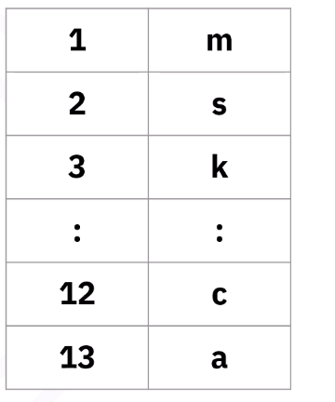.
We will be talking about states. With LangGraph you can construct and manage complex, multidimensional state structures. We generally define state with TypeDict, but you can also use Lists, nested structures.
​In LangGraph, you can define state variables, such as 'n' and 'letter', using a TypedDict class. ​Use the typing module to specify variable types. ​This class, a TypedDict subtype, acts as a dictionary with typed information. Within ​this class, define 'n' as integer and 'letter' as a string. Create a chain state object, ​which is essentially a typed dictionary. This represents a row of your table and supports ​complex types.
Lets see how to define a state structure with TypeDict:
In case you are wondering what is TypeDict : https://chatgpt.com/c/69e6582d-56f4-83e8-ad93-188b0ab5b416
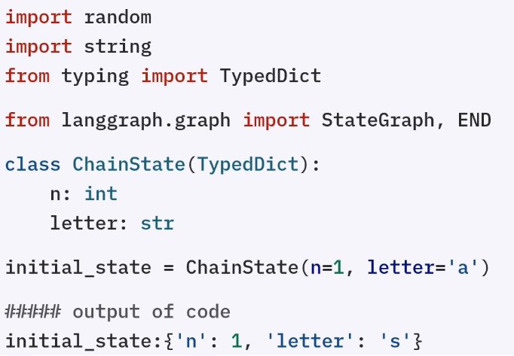. Now that we have defined our state, let’s see nodes.
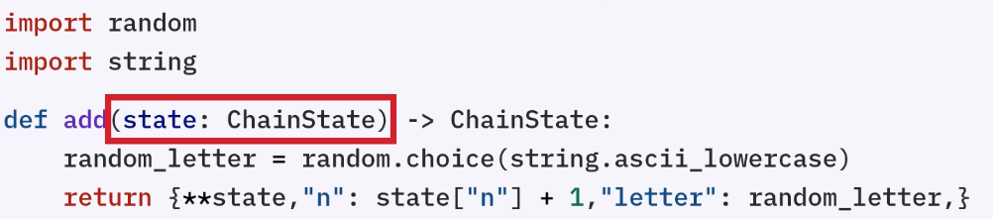
Nodes are functions that processes state. In this eg. As you can see that node is taking state as an input(ChainState object i.e. state). Inside the function we are generating a random letter in order to assign to the next state. The return statement uses the double star to unpack the original ​dictionary, increments 'n' by 1, and assigns the new letter to the letter field. ​The result is a chain state object.
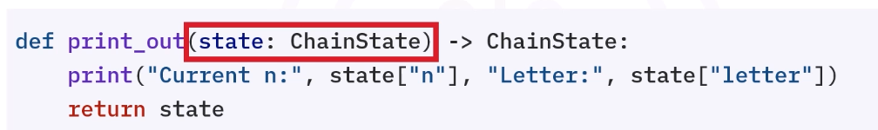
In this e.g. this node simply returns the state unchanged after printing n and letter.

The first step is to create a state graph object with your chain state class.
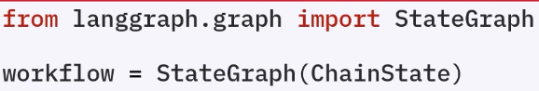
Another kind of state is END node, which indicates that the workflow is complete. 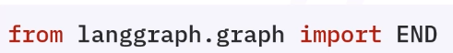
Once we have defined the workflow using StateGraph, we can add nodes which we had defined above(add and print_out):
add_node uses two arguments node’s name and function.
So just like that we have two nodes. 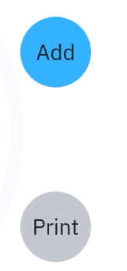
Now time to add edge between these nodes (edges define ​transitions between nodes based on conditions):
We add an edge using add_edge function and in the arguments giving first parameter is starting node and the second one is destination node.
After add node increments state, the updated state automatically passes to print.
Special edges control next node processing. These are directed by functions evaluating ​the current state. For example, checking if 'n' is greater than or equal to 13 and returning ​true or false.

1. Stop condition function
def stop_condition(state: ChainState) -> bool:
return state["n"] >= 13
- state → shared data flowing through the graph (like a mutable dictionary)
- state["n"] → some counter value in the state
- This function returns:
  - True → if n >= 13 → stop
  - False → if n < 13 → continue

2. Conditional edge logic
workflow.add_conditional_edges("print", stop_condition, {
True: END,
False: "add",
})
This means:
- After the "print" node runs, LangGraph:
  - Calls stop_condition(state)
  - Checks result:

If True:
➡️ Go to END → workflow stops

If False:
➡️ Go to "add" node → continue execution

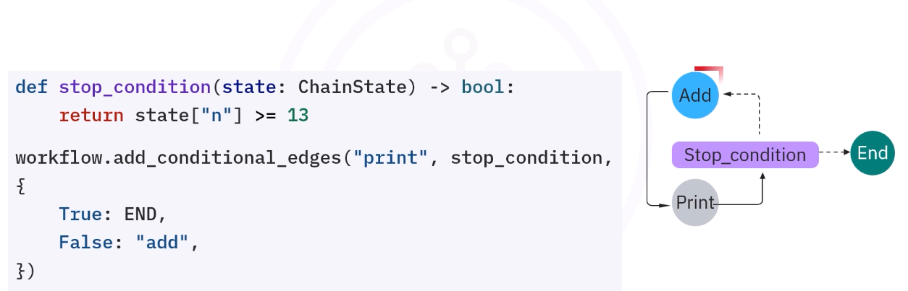

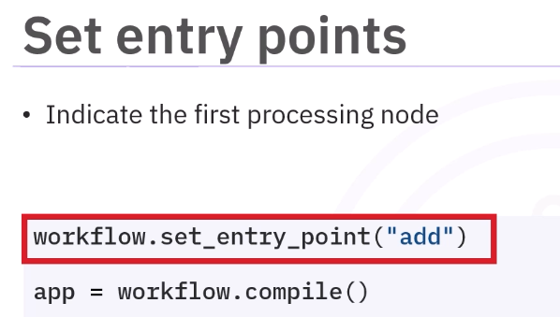
After connecting all nodes, call compile to build the runnable app. 